**Title:** Analytical Report - [**LinkedIn Top Skills**](https://public.tableau.com/app/profile/matt.chambers/viz/LinkedInTopSkills2016-MakeoverMonday/LinkedInTopSkills2016-MakeoverMonday)

The LinkedIn Top Skills of 2016 dashboard in figure (1) provides valuable insights into the skills rankings of the global job market. In statistical representation, it breaks down globally and 14 countries. In this report we will discuss three valuable insights.

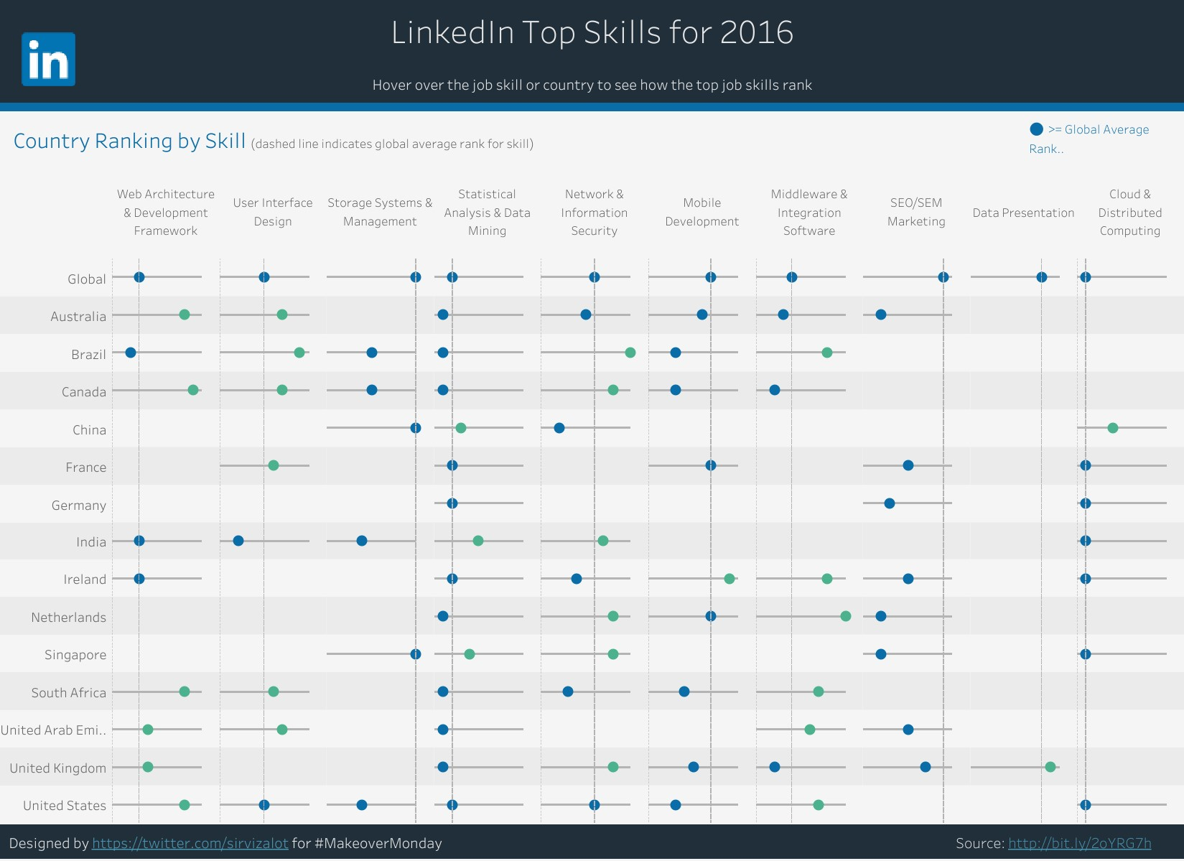

Figure 1 (LinkedIn Top Skills of 2016 dashboard)

**Insight 1:**

As we can see in figure 2, we can observe that the cloud computing and distributed computing skill is ranked as the best skill in the world in 2016. And also in different countries, including Germany, India, France, Ireland, Singapore and the United States. It demonstrates that it is worthy of global attention and highlights its role in meeting market needs and digital transformation globally.

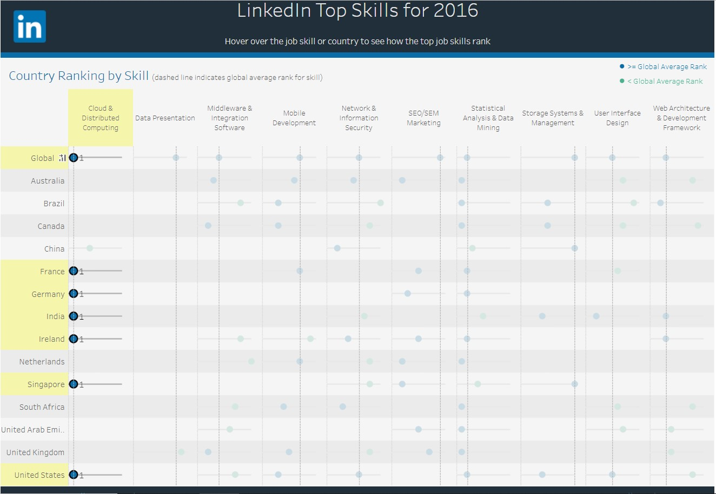

Figure 2 (cloud computing and distributed computing skill rank)

**Insight 2:**

From the below figure, we can observe that the Statistical Analysis and Data Mining skill ranked as a second most in-demand globally. Also, it is ranked in the top skills lists in different countries, demonstrating its global importance. It’s spread around the world reflects an important shift towards leveraging data for efficiency and competitiveness also it shows the globally permanent need to the professionals capable of dealing with complex datasets.

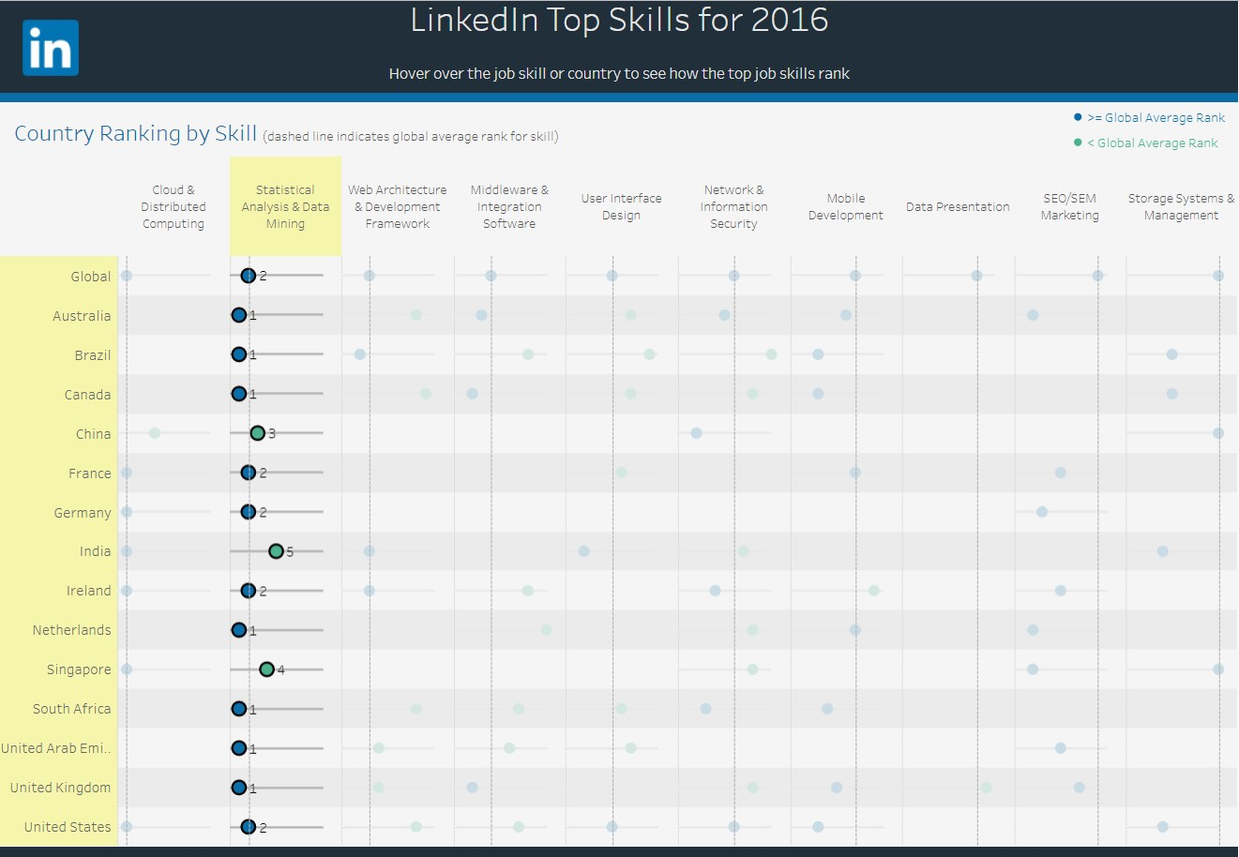

Figure 3 (Statistical Analysis and Data Mining skill rank)

**Insight 3:**

We can observe from Figure 4 that the storage systems and management skill may not appear prominently globally, but it worthy of attention in some countries and different industries and may be of particular importance for inclusion among LinkedIn top 10 skills. This demonstrates the extent to which employers need professionals in the job market capable of managing storage solutions to ensure easy access to and reliability of data.

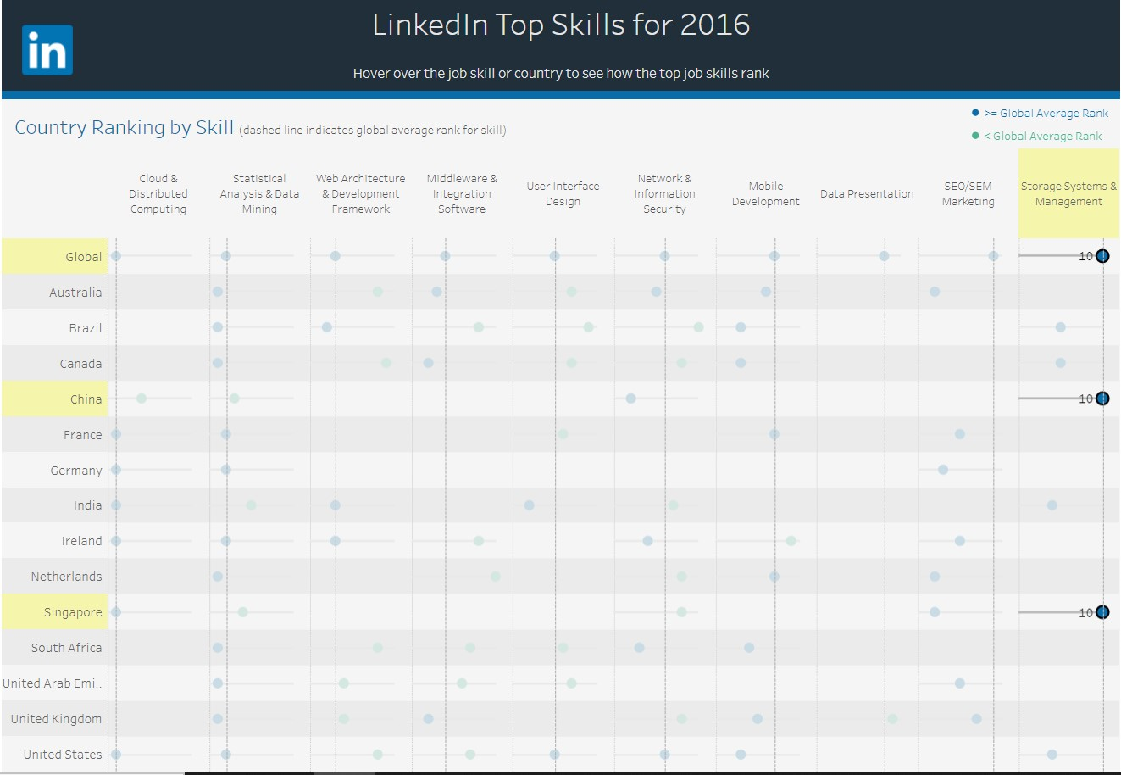

Figure (Storage Systems & Management skill rank)